# DMC Problem 12.66(e)

**Radio frequencies 1, 2,… are assigned to stations A through F. Two stations cannot be assigned the same frequency unless they are at least 100 miles apart. Pairs of stations which are within 100 miles of each other are highlighted with a red dot in the table. Assign frequencies to the stations using the minimum number of frequencies. Prove that you used the minimum number of frequencies.**

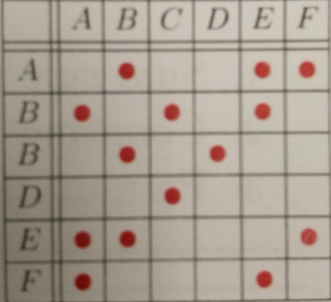

# DMC Problem 15.4

**You and a friend each toss two fair coins. All coins are tossed independently. Compute the probability that you get more heads than your friend.**

# DMC Problem 16.3

**There are 2 opaque bags, each with 2 balls. One bag has two black balls; the other a black and white. You randomly pick a bag and randomly take a ball from the bag. Your ball is black. What is the probability that the second ball in the same bag is black?**

# DMC Problem 18.6(a)

**Your LAN is two disjoint networks (see right), with two special nodes A, B. You randomly pick two different nodes in the network and every pair of nodes has equal probability of being picked. You add a new network link between the two nodes you picked.**

**(a) Compute the probability that there will be a path from A to B.**

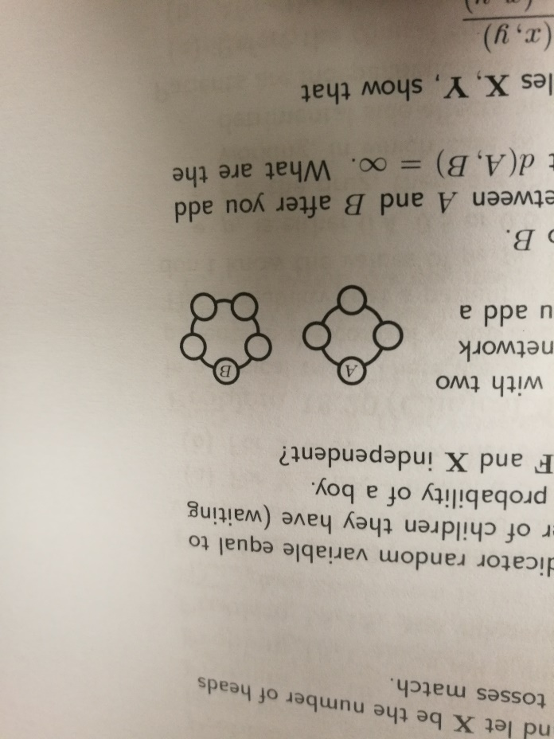

# DMC Problem 18.6(b)

**(b) Let d(A, B) be the number of links of the shortest path between A to B after you add your new link. If the network is not connected we say d(A, B) = ∞. What are the possible values for d(A, B) and compute their probabilities.**

# DMC Problem 19.9(a)

**You need to set a password as a string which is a permutation of the digits 0,1,2,3,4,5,6,7,8,9. Your birth day is 12/14 (Dec 24), and so for safety purposes, your password should not contain either of the substrings 12, 24. For example, 0213456789 is ok, but none of {0123456789, 0132456789, 987654321, 0113456789, 0312456789} are acceptable.**

**(a) How many possible passwords can you set?**

# DMC Problem 19.9(b)

**(b) If you pick passwords using independent random permutations, with each permutation being equally likely, what is the expected number of tries before you get an acceptable password.**

# DMC Problem 19.9(c)

**(c) Assume you generated your password by the process in (b). A hacker can test 100,000 passwords per second. The hacker randomly generates a permutation to test, each time independently. What is the hacker’s expected time to hack into your account.**

# DMC Problem 19.9(d)

**(d) What is the expected hack-in-time if the hacker systemically tries each password from 0123456789 to 9876543210?**

# DMC Problem 20.11(a)

**The dangerous chemical compounds C1, C2,…, Cn, n ≥ 4, must ne placed in buckets B1,…,Bk. Compound Ci is explosive if placed in the same bucket as compounds {Ci-3,Ci-2,Ci-1,Ci+1,Ci+2,Ci+3} (the ones that exist from this set). For example, C3 is explosive with C1, C2, C3, C4, C5, C6. An explosive pair of compounds will result in a disaster if they are placed in the bucket. This problem deals with the minimum number of buckets (minimum k) for which you can place all the compounds in the buckets safely.**

**(a) Show that you need at least 4 buckets and at most n buckets, 4 ≤ k ≤ n.**

# DMC Problem 20.11(b)

**(b) Show that you can safely put the compounds into 4 buckets and at most (k = 4 suffices) for all n ≥ 4.**

# DMC Problem 20.11(ci)

**(c) Let n = 10 (you have 10 compounds). Suppose you independently place the compounds randomly into 4 buckets with each bucket having probability ¼ . Compute:**

**(i) The probability that C1 is in a bucket with an explosive partner.**

# DMC Problem 20.11(cii)

**(ii) The probability that C4 is in a bucket with an explosive partner.**

# DMC Problem 20.11(ciii)

**(iii) Compute the expectation of the number of explosive pairs created.**